End of year 2011 Inspection Report to AUMA

by Green Charity Foundation (Dec. 2011)

An inspection trip was carried out by Dr. & Mrs. Tang, and Grace Lo between 26th and 29th Oct. 2011, to follow up the progress of the reforest program sponsored by AUMA at Si Jiang village, Shi Lou, Shanxi.

The details are as below:

1. The designated area of the AUMA sponsored reforest area is Area 21 ( 139 acres) of Si Jiang Village . All trenches for seedling planting were dug by village laborers in the middle of this year. As shown in the photos below :

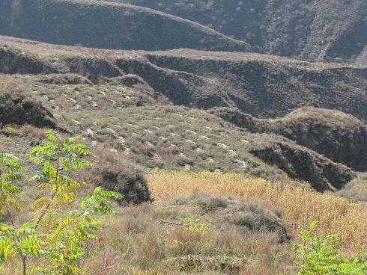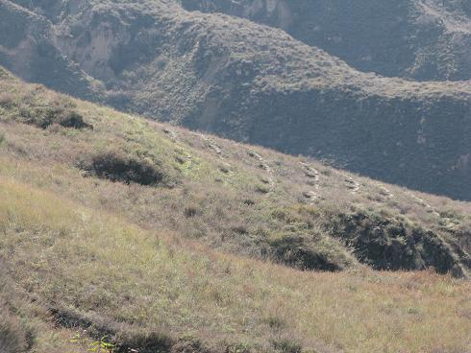

-1-

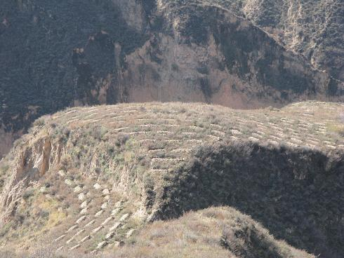
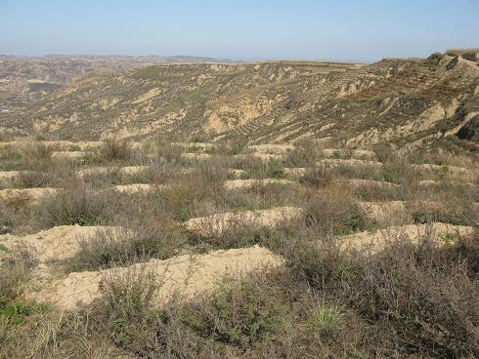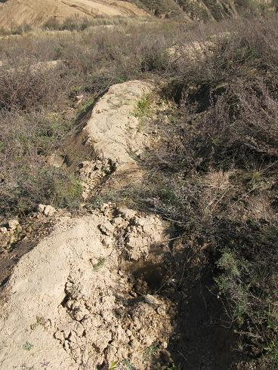

- The planting of seedlings for this season had just started when we arrived at the Village on 27th Oct. As we climbed up the hilly path to the site, we saw seedlings were delivered on sites, waiting to be planted. Also, there were husks been piled up at the side of the path, to be mixed into top soil for refilling the trenches after seedlings been planted . Photos are shown as below:

-2-

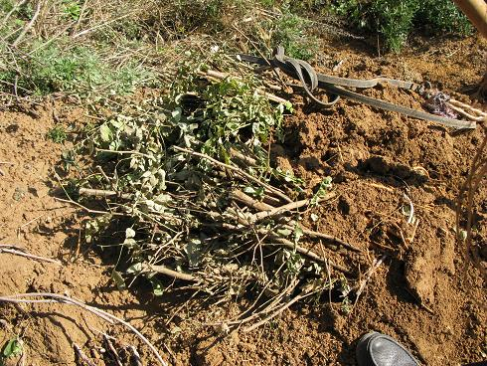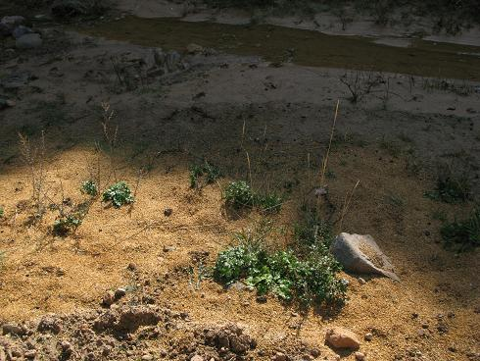

- Seedlings had been carefully chosen and trimmed for better results. Besides, all seedlings to be planted for the day were carried to the site in two groups, some in the morning, the rest , after lunch. This is to avoid leaving young seedlings exposed to sun for too long , in order to keep them in good shape for planting. Photos taken on site are shown as below:

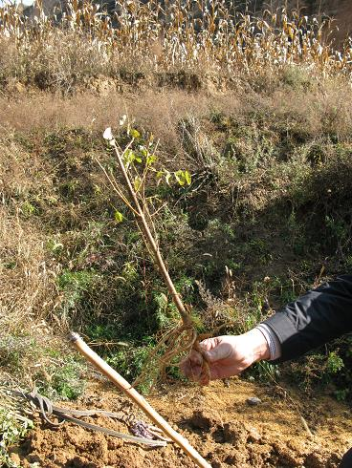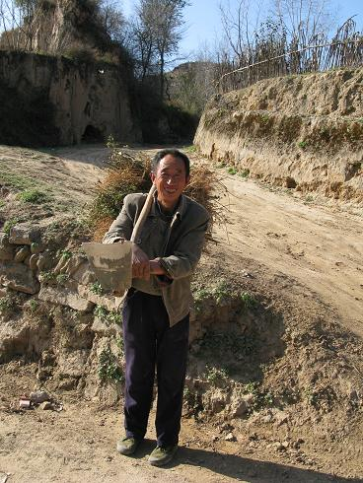

-3-

- On planting site, there is also a supervisor , checking on all work been carried out
Properly .

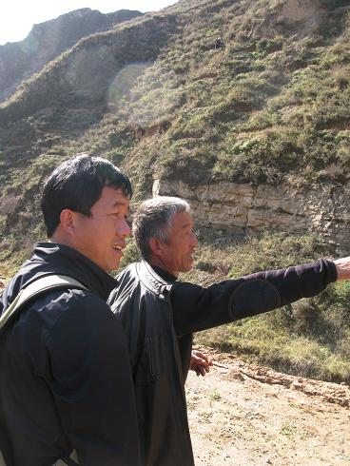

- There is a small section of area 21 been disturbed by the construction work of the local natural gas pipe . Our Contractor, Mr. Wen, promised to repair all damaged trenches before seedlings been planted.

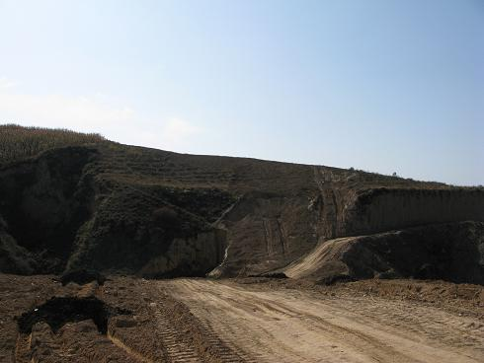

-4-

6. We received reports from Si Jiang Village that all seedlings planting had be completed
by the end of November. A total of 30,580 nos. of mixed seedlings had been planted,
they included: 刺 槐， 杏， 山桃，側柏， 文冠果，火炬。 The husks are yet to
be applied around all newly planted seedlings in the coming spring time. The
contractor decided to postpone this procedure for the safety of workers. Because
the site was very damp and slippery due to heavier rainfall this autumn and a heavy
snowfall right after the planting work.

7. The outlook of AUMA Project for the year of 2012:

Members of Green Charity Foundation will double check in spring of 2012 to make sure husks are applied as soon as the weather and workforce allow.

As tree trenches were dug properly, seedlings were carefully chosen, trimmed, and
planting work was carried out accordingly, together with higher than average rainfall of this
autumn, heavy snowfall right after planting work finished in Si Jiang area, we expect the
young trees to grow well in next spring.

-5-

